Introduction to Java

CS9053 Section I2

Wednesday 6 PM – 8:30 PM

Prof. Dean Christakos

Sept 27th, 2024

Due: Oct 4th, 2024 11:59 PM

**Assignment 4**

Part I: Inheritance

1. Here is a class hierarchy diagram for library items. I have added the fields but you can figure out the getters and setters and constructors for yourself.

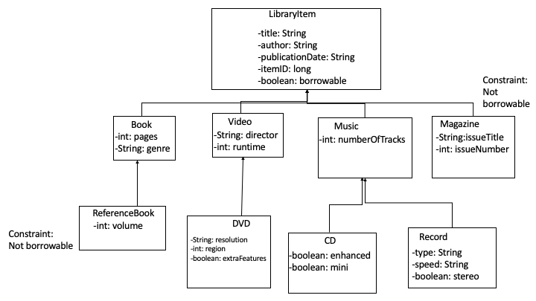

There should be appropriate getters and setters for each of these fields as well as toString() methods. There should also be equals() methods and in this case, the equals method should also check the itemID

1. You will notice that I said that Magazine and ReferenceBook objects have a constraint that they are not borrowable. Design constructors and override methods appropriately to ensure that the borrowable field is always false for these objects.

Part II – Arraylists

1. Now, remember the library from the last problem set?

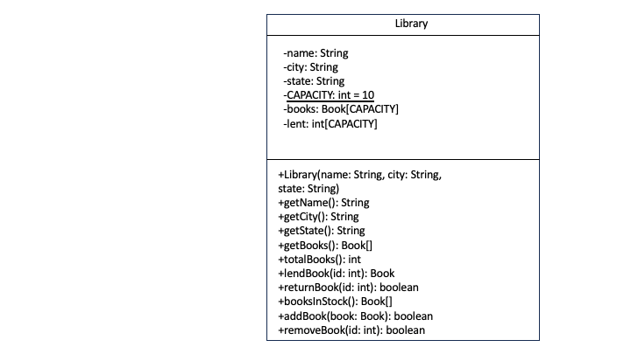

Reimplement this (you can use as much of your old code as you want) to use ArrayLists that stores LibraryItem objects instead of Book objects. (anything referring to “Books” should be replaced with “Items” in the code). Attempting to remove an unborrowable item should be prohibited by returning null in LendItem.

lendItem, returnItem, and removeItem should also have overloaded implementations that take a LibraryItem argument as well as an Id argument.

Create some objects and show that it works.